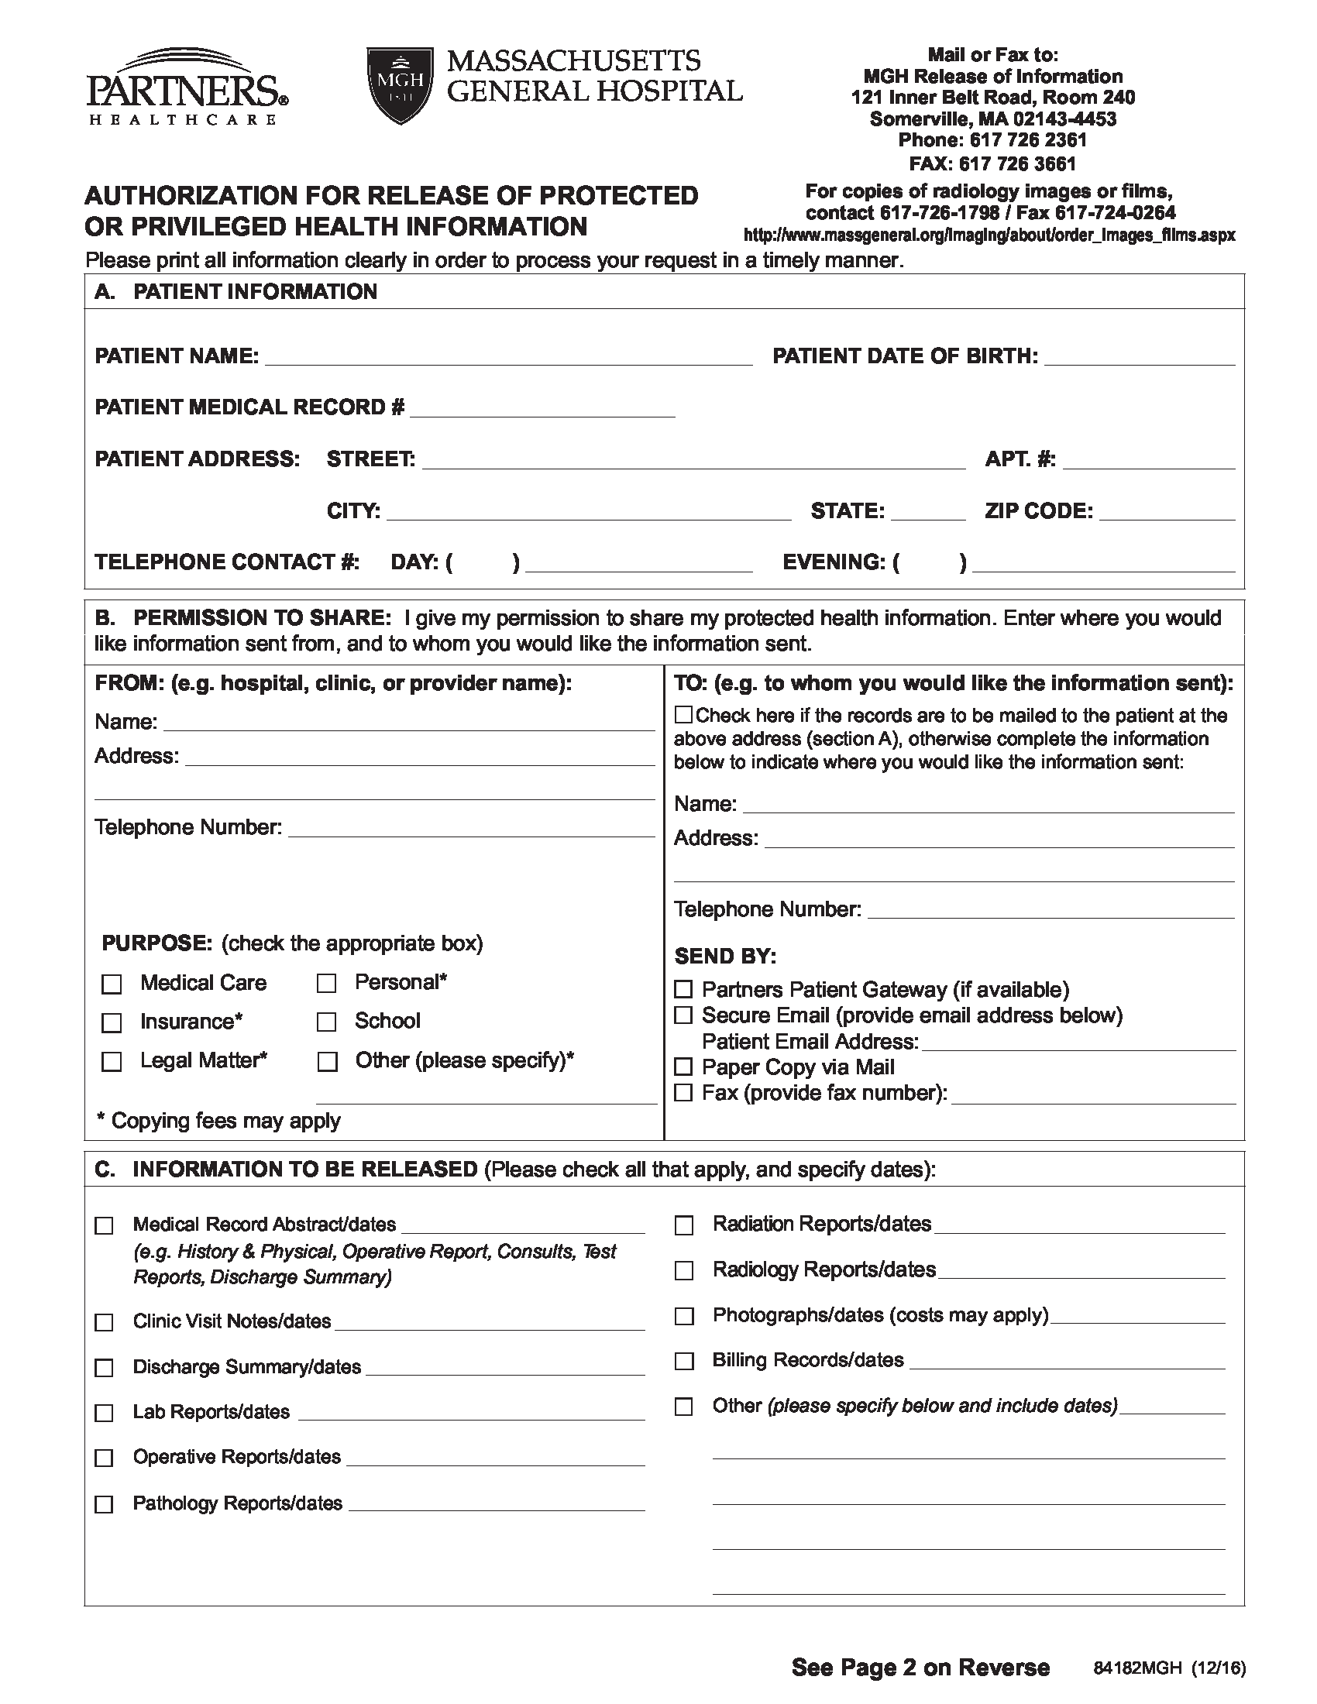
Batman
01/01/1979
Secret Location
Gotham
NJ

University of Michigan Hospital and Health Center
2901 Hubbard Street Room 2722
Ann Arbor, MI 48109-0000
(734) 936-5490
Axiom Requisition Copy Service
2869 Jolly Road
Okemos, MI 48864
(877) 886-5090
(517) 886-4116
✓

✓

FROM 01/01/1979 TO PRESENT: Any and all MEDICAL RECORDS, including but not limited to patient history form(s), reports, etc. pertaining to Batman SSN: xxx-xx-5555, DOB: 01/01/1979.













